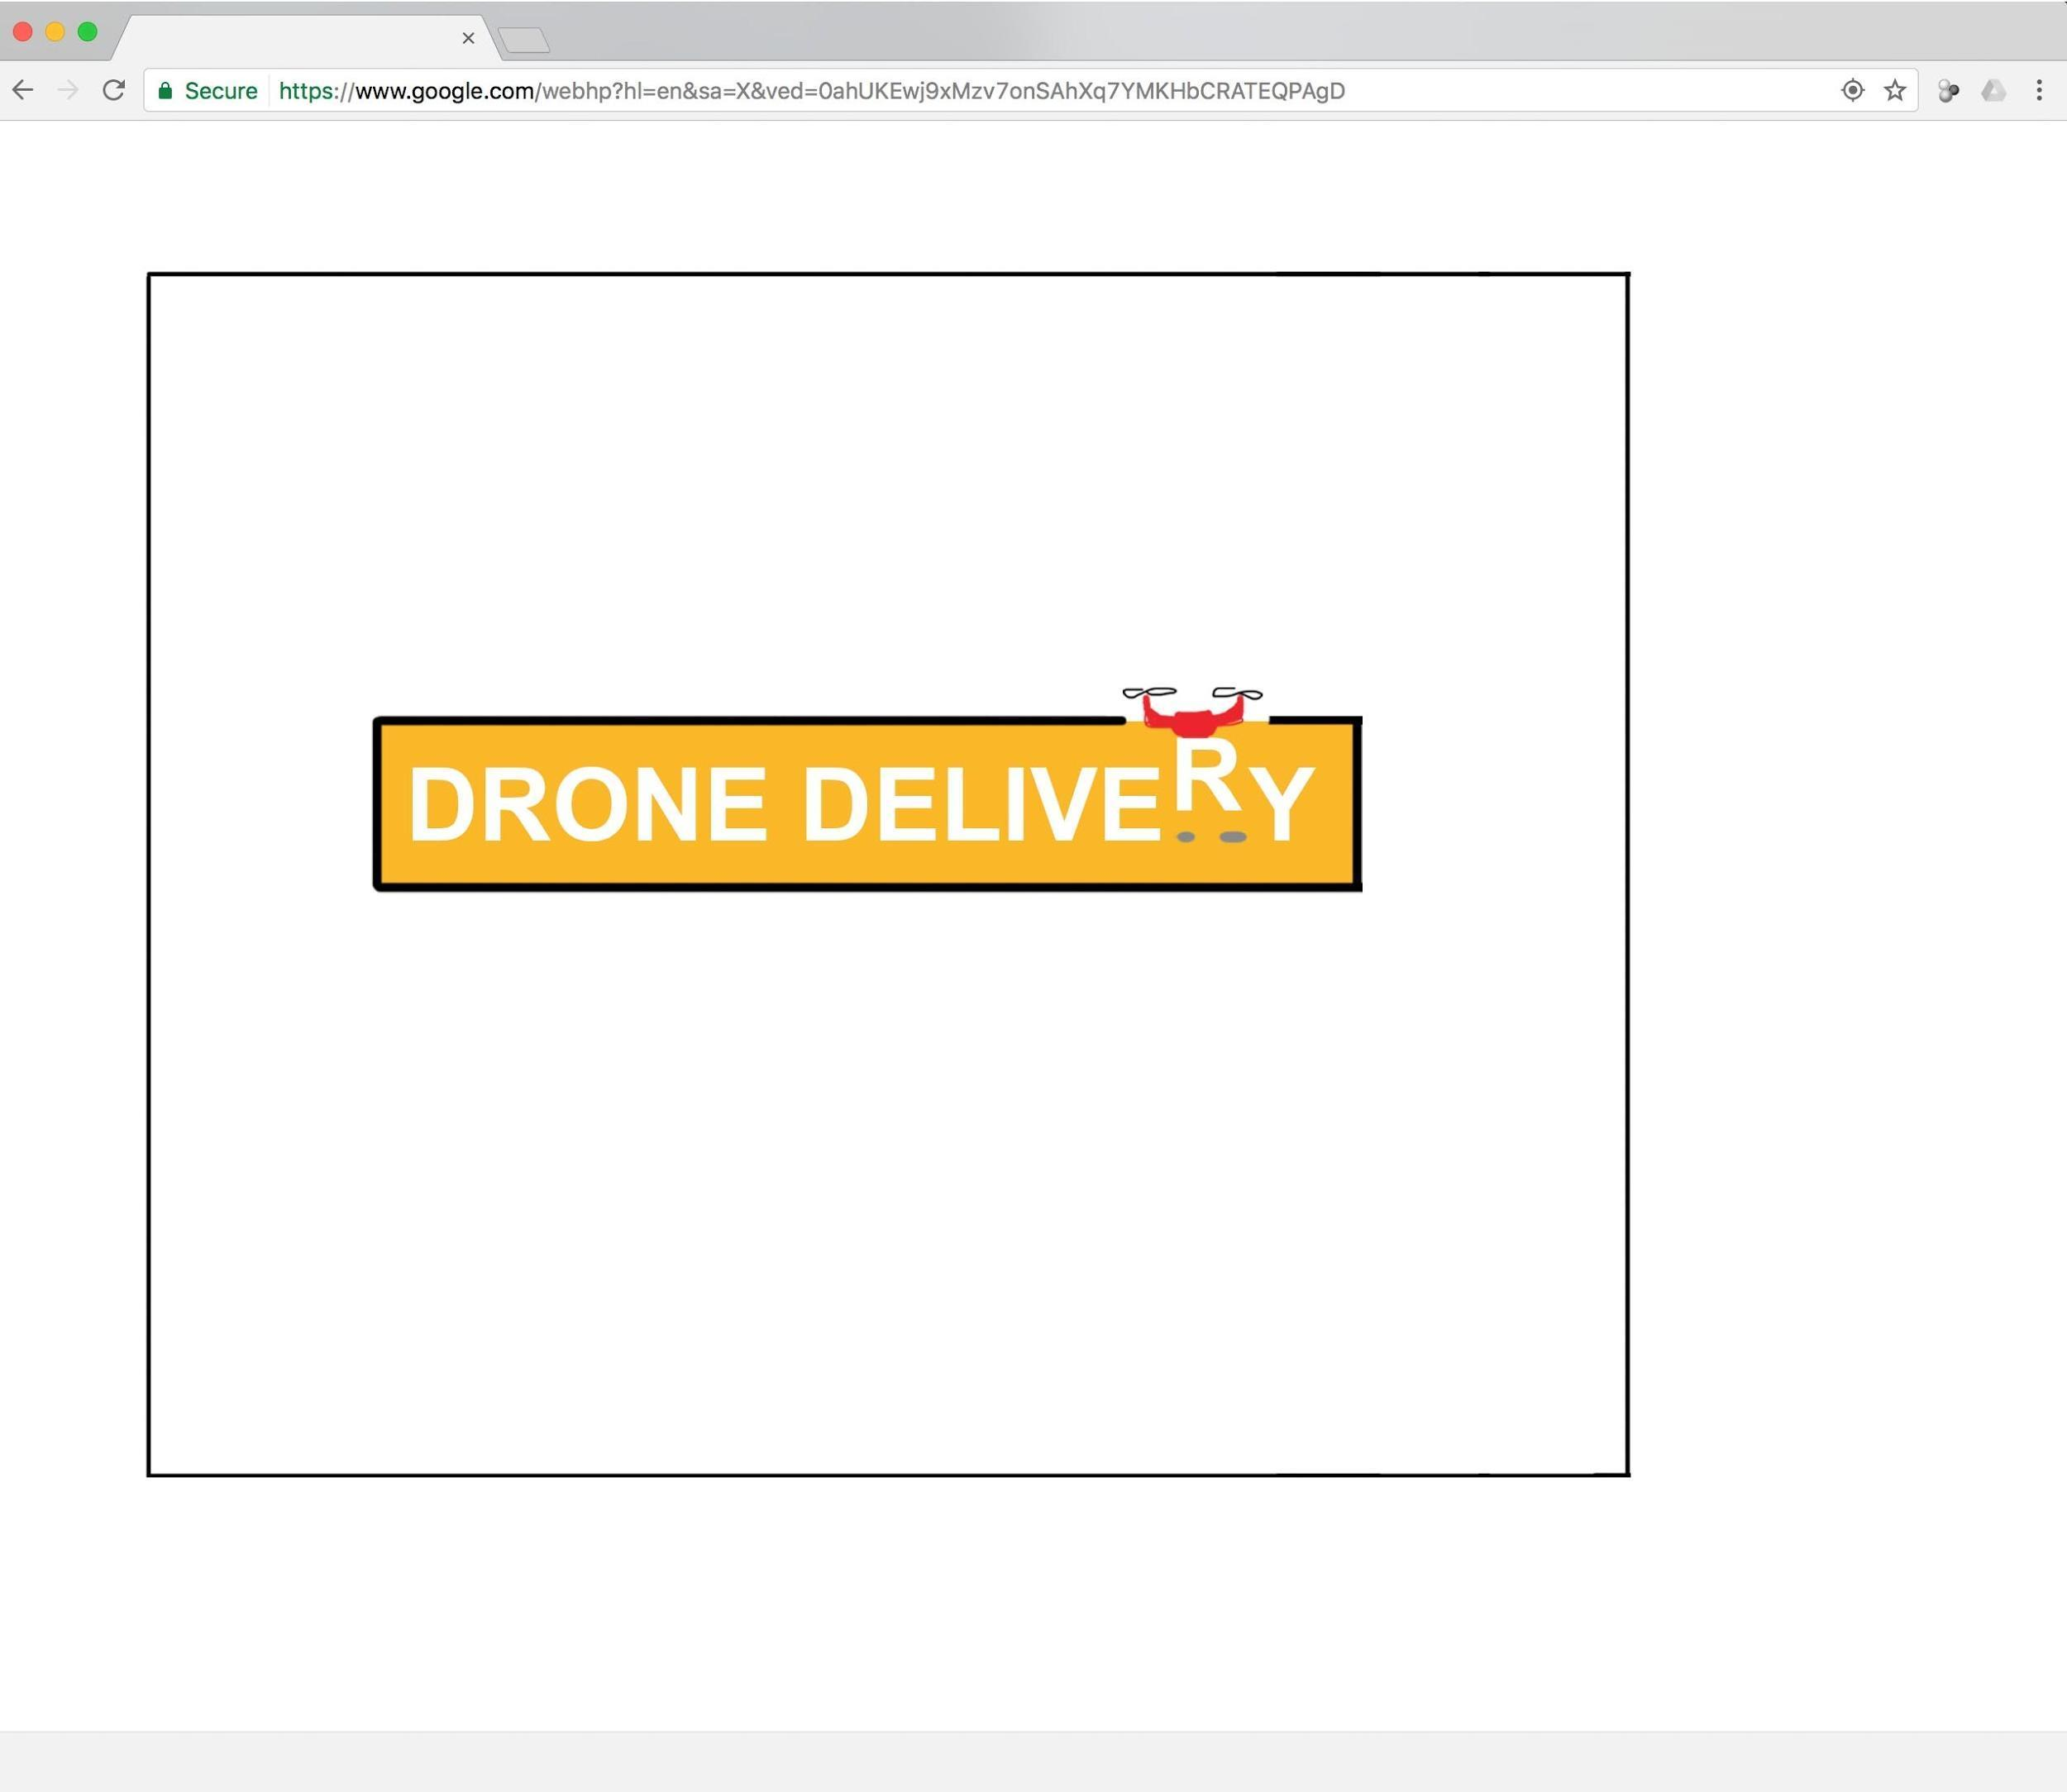

**Project Goal**

Our goal is to develop the first full level of Drone Delivery. We have successfully completed that goal.

**Game Specification & Description**

(See Readme)

**Assets (Updated)**

Our game includes the following assets we have been learning about:

* Bitmaps: course background image
* Shapes:
  + Junior the Drone
  + The Parcel
  + The Ocean
  + Drop Zone
  + Walls & Platforms
* Sprites:
  + Birds
* Animation:
  + Bird objects will move side to side in intervals
  + Ocean will have visualization of water moving
  + Junior the Drone’s propellers “revolve” at different speeds whether coasting or flying upward
* Input:
  + Keyboard and mouse will be used to control Junior and activate game features
* Containers:
  + The Drone is inside a container
  + The Parcel is added to this container if the Drone picks up the Parcel
* Sprite Animation:
  + The Bird has flapping wings made of different frames of the spritesheet

**How Our Game Is Different or Unique (Updated)**

Our game is a platform game, but most platforms have a player that moves along the ground (can’t fly). By making our drone fly, we’ve made possible a whole new set of challenges and scenarios, such as not being able to touch the ground or needing to navigate vertically as well as horizontally.

We’ve also added the ability to carry an object around and have that object interact with the world, which adds an extra dimension to gameplay. In this way, there are many more possibilities for interacting with the world. The Drone could lift objects and set them on switches or drop them on enemies.

Our game requires a combination of keyboard and mouse interaction to guide the Drone around the course. Rather than a simple D-Pad or only using the Mouse, players must use coordination to successfully navigate.

Finally, the theme of flying drones is new to 2D style games, and adds a modern flair!

**How Our Game Has Changed (original vision to final version):**

We scaled back the scope of the game after realizing we had taken on too much.

* We removed the concept of Power-Ups (Power Packs)
* We removed the concept of needing Battery Power to fly
* We removed the concept of Lives
* We scaled back the number of sprite animations we had originally planned to do (explosions when something was destroyed)

We believe our game demonstrates achievement in all of the major class topic areas without these added elements.

**Credits / Backlog**

D: Drone P: Package O: Objects PP: Power pack GUI: GUI G: Gameplay

| Item | Phase | Type | Responsible | Completed? |
| --- | --- | --- | --- | --- |
| **(by February 13) Phase 1** | **1** | **-** | **together** | **X** |
| Add ability for drone to pick up objects | 1 | D | Ryan | X |
| Add background as bitmap | 1 | O | Ryan | X |
| Add Collision Detection (drone) with game objects, game frame | 1 | D | Ryan | X |
| Add Collision Detection (Package) | 1 | P | Ryan | X |
| Add Drone movement controls | 1 | D | Ryan | X |
| Add drop zone event | 1 | G | Jack | X |
| Add in-game pause menu / text | 1 | GUI | Jack | X |
| Add interaction b/w drone and hazards | 1 | D | Ryan | X |
| Add interaction b/w package and hazards | 1 | D | Ryan | X |
| Add Package movement ability (independent of drone / dependent on drone) | 1 | P | Ryan | X |
| Add pause functionality | 1 | G | Ryan | X |
| Animate Drone propellers | 1 | D | Ryan | X |
| Design container, add to game | 1 | O | Ryan | X |
| Design Drone, add to game | 1 | D | Ryan | X |
| Design Drop Zone, add to game | 1 | O | Jack | X |
| Design Game background | 1 | O | Ryan | X |
| Design Ocean, add to game | 1 | O | Ryan | X |
| Design The Package, add to game | 1 | P | Ryan | X |
| Design Wall and platforms, add to game | 1 | O | Ryan | X |
| **(by Feb 22)** **Phase 2** | **2** | **-** | **together** |  |
| Add “new game” space bar functionality to pause screen | 2 | G | Ryan | X |
| Animate Ocean (water movement / waves) | 2 | O | Ryan | X |
| Implement generic wall creation method | 2 | O | Ryan | X |
| **(by Feb 27) Phase 3** | **3** | **-** | **together** |  |
| Add end-course event (timer runs out) | 3 | G | Ryan | X |
| Add end-course/ end-game notification popup in-screen, pauses game after winning or being destroyed | 3 | GUI | Ryan | X |
| Add Game Start Screen | 3 | GUI | Ryan | X |
| Add game timer functionality | 3 | G | Ryan | X |
| Add game timer visualization | 3 | GUI | Ryan | X |
| Add paused game text at beginning of each course | 3 | GUI | Ryan | X |
| Animate Birds (fly side to side) | 3 | O | Jack | X |
| Design Birds, add to game | 3 | O | Jack | X |
| Design Sprites, add to game | 3 | O | Jack | X |
| **(by March 6) Phase 4** | **4** | **-** | **together** |  |
| Add comments and description to code, finish readme | 4 | C | Ryan | X |
| Add comments to code | 4 | C | Jack | X |
| Add explanation of gameplay / goal at beginning of game | 4 | GUI | Ryan | X |
| Add level number visualization | 4 | GUI | Jack | X |
| Add Sprite animation to game | 4 | O | Jack | X |
| Design Sprite animation | 4 | O | Jack | X |
| Diagram the functions and relationships of the code | 4 | C | Ryan | X |
| Improve differentiation of movement of drone and package, such as:   * drone falls faster than flying upward * package retains same horizontal speed when dropped from drone | 4 | D | Ryan | X |
| Improve Drone propellor design and animation | 4 | D | Ryan | X |
| **(March 6, 8, 10) Presentation** | **5** | **-** | **Together** |  |